Accessing the **Parent Portal**:

1. Go to <https://www.wpschools.org>.
2. In the upper right hand corner, select the icon for Parent Portal.

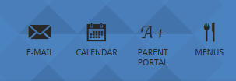

***\*NOTE***: You can also go directly to the parent portal login page by visiting <https://www.fridayparentportal.com/westpaterson>.

1. Enter your login credentials (code, username, and password).

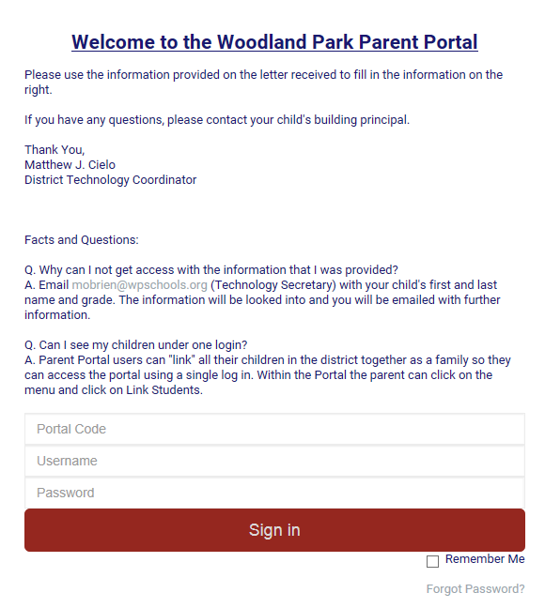

Accessing the **Student Portal**:

1. 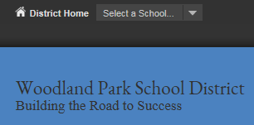Go to <https://www.wpschools.org>. In the upper left hand corner, click “Select a School” and click “Memorial Middle School”.

\****NOTE***: You can also go directly to the student portal login page by visiting <https://www.fridaystudentportal.com/westpaterson>.

1. 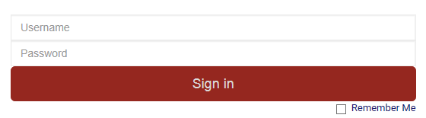Have your child enter their username (5690 + their 5 digit lunch code) and password (created by them).

Navigating the **Parent Portal:**

While in the Parent Portal, you will have access to various departments via the Menu tab on the left hand side:

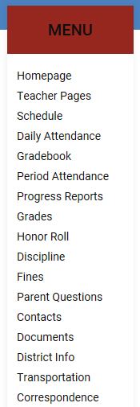

* To visit your child’s teachers’ pages
* To view your child’s schedule
* To view your child’s daily attendance
* To view your child’s current grades
* To view your child’s progress reports
* To view your child’s report cards
* To view any discipline reports on your child
* To view any fines your child owes
* To answer survey questions from the district
* To view and edit emergency contact information
* To view any related documents from the school
* To view information about our district
* To view transportation related information
* To view any correspondences from the school

Navigating the **Student Portal:**

Your child’s student portal works exactly the same as the parent portal, however they have access to less options in their Menu tab. They will only be able to see:

* Teacher Pages
* Gradebook
* Schedule
* Attendance
* Testing (PARCC/NJASK Scores)

Navigating **Teacher Pages:**

Once selecting the “Teacher Pages” tab from the menu, you will be able to access your child’s teachers’ specific homepages where they will have resources such as syllabi, assignments, supplies, contact information, and other important notes for their class. To access these pages:

1. Select the “Teacher Pages” tab from the menu on the left hand side. A table of your child’s classes, room numbers, and respective teachers will appear.
2. Click the corresponding grey text on the right hand side of the table of the page that says “Teacher Page” to view that teacher’s site.
3. If you want to contact a teacher, click on the name of the teacher in the table. This will open up whatever email application you use on your computer and automatically fill in the email address of the teacher you’d like to contact.

Navigating **Gradebook:**

In this section, you will be able to view an up-to-date log of your child’s grades. To view your child’s grades in any class:

1. Select the “Gradebook” tab from the menu on the left hand side. A table of your child’s classes, current average, and teacher name will appear.
2. To view a detailed log of graded assignments in a specific class, click the corresponding grey text on the left hand side of the table with name of the class you are looking to access.
   1. Once you’re looking at the detailed log of grades, you can click the red and black arrows next to each assignment to view any comments the teacher may have included regarding its completion.
   2. You can also view information about each assignment including its due date, the total number of points the assignment was worth, and the grade your child received.

Updating Your Child’s **Emergency Contact Information:**

1. Select the “Contacts” tab from the menu on the left hand side.
2. To add an emergency contact for your child, scroll to the bottom of the page and select “Add Additional Contact”. Complete the form and click “Submit” at the bottom of the page.
3. To update/change information for an existing contact, click “Update Phone/Email”. Here, you can edit any information for the specified emergency contact. You may also indicate whether or not you’d like to receive district-related calls or text messages.

**Troubleshooting**

*Logging in for the first time?*

1. If you have never logged into the Parent or Student Portal before, contact Mrs. O’Brien for your introductory code, username, and password.
2. Once you have received the preliminary information, enter it into the corresponding login boxes (see page 1 on how to access this site).
3. You will then be prompted to create a new password for your account.
4. After submitting your new password, you will again be prompted to login with your existing code, username, and newly created password.

*Not receiving school texts and/or emails?*

1. In your parent portal, select “Contacts” from the menu tab. Under the corresponding contact listing, select “Update Phone/Email”.
2. Check off the corresponding box for “Call” and/or “Text”.

*Wrong username and/or password?*

1. Make sure you are entering your codes, usernames, and passwords correctly, as those credentials are case sensitive!
2. Make sure you have entered your credentials in the correct order: code (5690 + your child’s 5-digit lunch code), username, then password.
3. If you forgot your password, click the text under the login fields that says “Forgot Password?” Here, you can have your password sent to the email address we have on file for you and your child.

***If you continue to experience any issues with the Parent and/or Student Portal, feel free to contact our Guidance & Technology Secretary, Mrs. O’Brien, at (973) 317-7782 or at*** [***mobrien@wpschools.org***](mailto:mobrien@wpschools.org)***.***